NAME: Lesedi
SURNAME: Mawasha
STUDENT NO: ST10483062
MODULE NAME: Web Development
MODULE CODE: WEDE5020

RESTURANT WEBSITE
- Organisation overview
. Jacky’s restaurant
. It is a restaurant in Aqua Park, Tzaneen (Limpopo, South Africa). This restaurant opened in late December 2025 at 5 Douglas street. It runs under a new management in a space that was previously occupied by another restaurant. It grew into local aesthetic hotspot for breakfast, grills, and social events.
. This restaurant’s mission is to give customers affordable meals and give customers pleasant experience an excellent customer service.
. This restaurant’s vision is to rank among the community’s most reputable and well-liked eateries.
. The target audience includes locals, visitors, working professionals, families, and students.
2. Web goals and objectives
. Showcase the ambiance of the restaurant with interactive photos and videos to create a great virtual dining experience.
. Permit clients to browse the menu online.
. Allow clients to make reservations for tables.
. Allow online orders.
Key performance indicators
. Boost the number visitors to your website
. Boost reservations made online.
. Boost client enquiries.
3. Current website analysis
. There is no website for the restaurant yet. Consumers rely on phone conversations and social media for information. Finding company information, making bookings, and viewing the menu are all made challenging by this.
Areas of improvement
. Create a professional website
. Display menus and operating hours
. Improve customer communication

Feature | Functionality
Home page | It welcomes a user or visitors and introduces the restaurant.
About us | It provides the restaurant’s history, mission, and values.
Menu | Shows food, drinks, prices, and food descriptions.
Online reservation | Allows customers to book tables online it can.
Gallery | Shows excellent quality pictures of the restaurant and images of meals.
Contact us | Includes email, address, Map, and phone numbers.
Customer reviews | Displays customer feedback from people who have experienced the restaurant.
4. Proposed website features and functionally

5 Design and user experience
. There will be warm colours such as pink and white to create a welcoming atmosphere
. It will be easy to navigate like having simple menus with clear layouts
. The website to be created should function well on phones, tablets, and computers.
. To attract customers food images should be of high quality.
. look & Design: A basic navigation menu, a large banner image and well organised sections make up this clean, contemporary look (Krug 2014; Bootstrap 2025).

6. Technical requirements
. Domain: www.jacky’s restaurant.co.za
. Programming languages: HTML, CSS and Java script
. Hosting: shared web hosting with daily backups
. Framework: Bootstrap 5 (Robbins 2018; Bootstrap 2025).

7. Timeline and milestones
Week | Task
Week 1 | Research and planning
Week 2-3 | Create wireframes and design
Week 4-6 | Develop the website
Week 7-8 | Test the website and fix issues
Week 9 | Final review and submission

8. Budget
. Domain registration: R500/ year
. Web hosting: R1.200/year
. Web development: R10,000
. Maintenance: R500/month
WIREFRAME
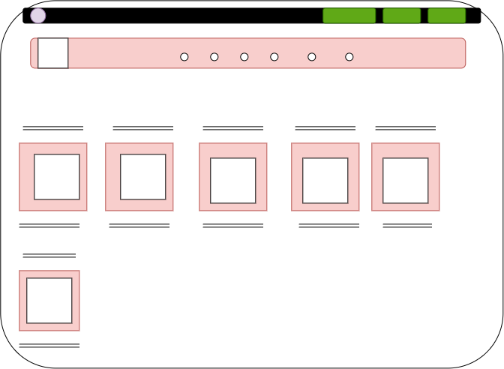

9. Reference
. Bootstrap 2025, Bootstrap documentation, Available at: https://getbootstrap.com/ (Accessed: 3 August 2026).
. Nielsen Norman Group 2024, user experience (UX) articles. Available at: https://www.nngroup.com/ (Accessed: 3 August 2026).
WEB PROPOSAL 2

GYM WEBSITE
- Organisational overview
. R36 Gym Lenyenye
. This is a local physical centre offering personal training, monthly gym access, and fitness training services alongside R36 road in Lenyenye in the province Limpopo. It was opened January 2021 just after the corona virus pandemic. The gym offers modern equipments (
. The gym’s mission is to: To encourage and enable people to lead healthier lives by providing them with professional assistance and high-quality fitness services.
. The gym’s vision is to: To become the community's top fitness facility by encouraging lifelong fitness, wellness, and health (Nielsen Norman Group 2024).

. Target audience includes adolescents and college students, professionals who are employed, fitness fanatics and elderly people seeking wellness initiatives.

- Web goals and objectives
. Permit online registration and membership management for members. . .Give members the option to schedule personal training sessions and fitness classes.
. Offer individualised exercise regimens and dietary advice.
. Use blogs and success stories to create an online fitness community.
. Advertise exclusive events and membership packages.
Key performance indicators
. 25% increase in online membership registrations.
. Make at least 100 reservations for online classes each month.
. Get an average customer rating of at least 4.5 stars.
- Current website analysis
. The gym does not have a website currently and is challenging for customers to obtain information, sign up for memberships, or schedule sessions online because they mostly rely on social media and phone enquiries.
- Proposed website features and functionality

Feature | Functionality
Homepage | Welcomes visitors and highlights promotions, membership offers.
About us | Introduces the gym, its mission, vision, and facilities.
Membership plans | Displays available membership packages, prices, and benefits.
Class schedule | Shows the timetable for fitness classes such as yoga.
Online bookings | Allows members to book fitness classes and personal training sessions.
Workout tips | Provides articles and advice to support members' goals.
Gallery | Displays photos of the gym, equipment, and classes.
Contact us | Provides the gym's location, phone number, email, map (Robbins 2018).

- Design and user experience
. Colour Scheme: Black and orange for a modern and energetic look.
. Typography: Poppins for headings and Open Sans for body text.
. Layout: Clean, modern, and easy to navigate.
. User Experience: Mobile-friendly, fast loading, and simple navigation.
. Wireframes: Home, Membership, Classes, Trainers, and Contact pages.
- Technical requirements
. Domain: www.R36 gym.co.za
. Programming languages: HTML and Java script
. Hosting: shared web hosting
. Framework: Bootstrap 5
- Timeline
Week | Task
Week 1-2 | Research and planning
Week 3-5 | Design wireframes and website layout
Week 6-10 | Develop the website
Week 11-12 | Test the website
Week 13 | Final review and deployment

- Budget
. Domain registration: R500/year
. Hosting: R2000/year
. Website development: R20,000
. Maintenance: R800/month

WIREFRAMES

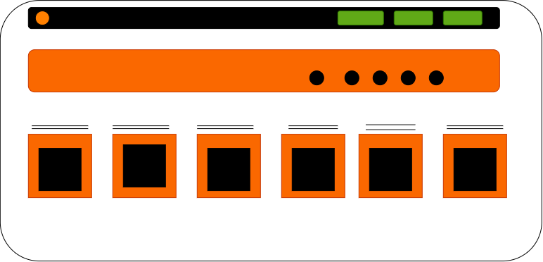

- Reference
. Bootstrap (2025) Bootstrap documentation. Available at: https://getbootstrap.com/ (Accessed: 3 August 2026).
. Planet Fitness (n.d.) Planet Fitness South Africa. Available at: https://www.planetfitness.co.za/ (Accessed: 3 August 2026).
. Nielsen Norman Group (2024) Articles on user experience. Available at: https://www.nngroup.com/ (Accessed: 3 August 2026).
. Robbins, J.N. 2018, Learning Web Design: A Beginner’s Guide to HTML, CSS, JavaScript, and Web Graphics: 5th ed. O’Reilly Media, Sebastopol.

PROPOSAL 1

4. WE BSITE STRUCTURE AND PLANNING

. Homepage

. About us

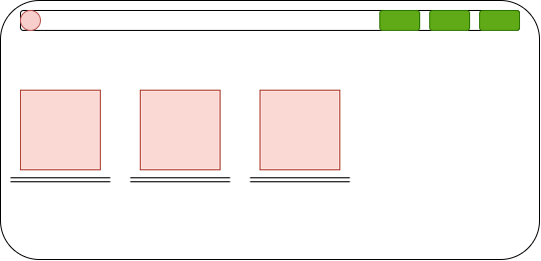

. Menu

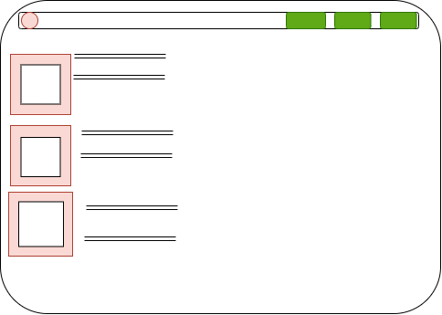

. Gallery
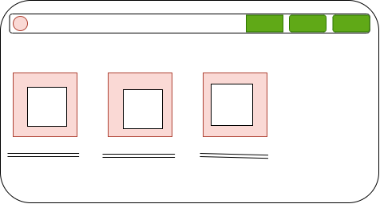

. Reviews
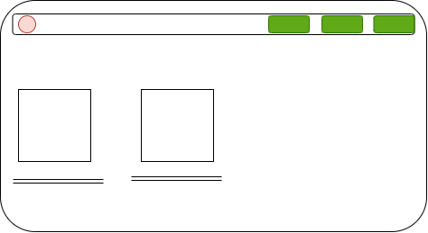

. Reservations
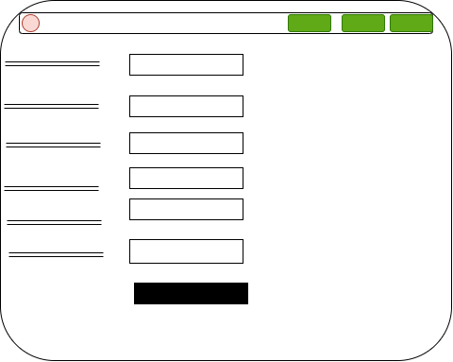
. Contact us


